To create a Parent Portal Account for Infinite Campus, click the
Hyperlink, read the Hall County School System Electronic Web Access Agreement for
Viewing Student Information policy and click the button. Continue signing up as follows:

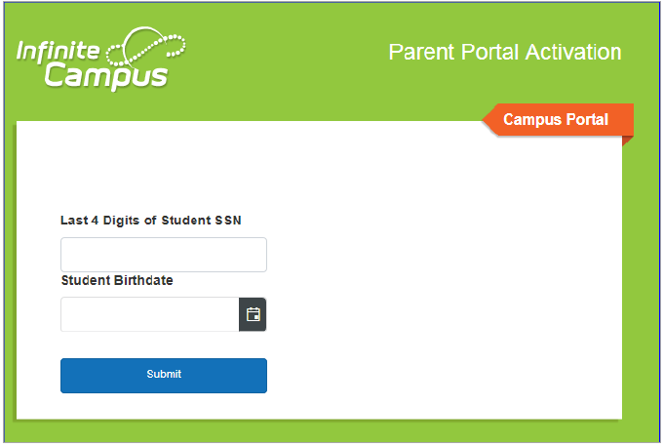
On the Portal Activation Key Lookup tool, enter your child’s Student's last 4 of SSN and Birthdate before clicking the Submit button:
A screen will open giving the GUID number for each guardian. Write this number down before clicking on the
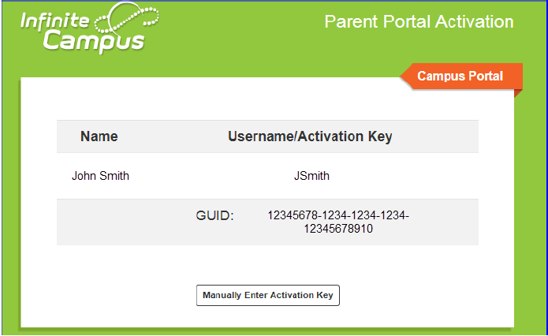
Manually Enter Activation Key button:
Enter the GUID number on the activation screen:
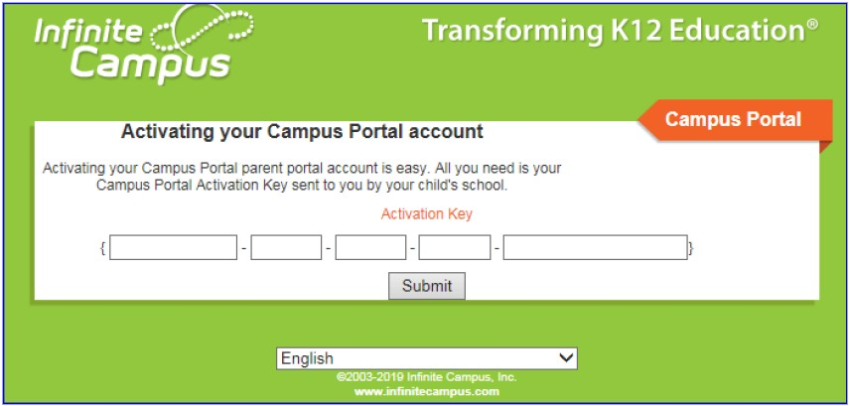

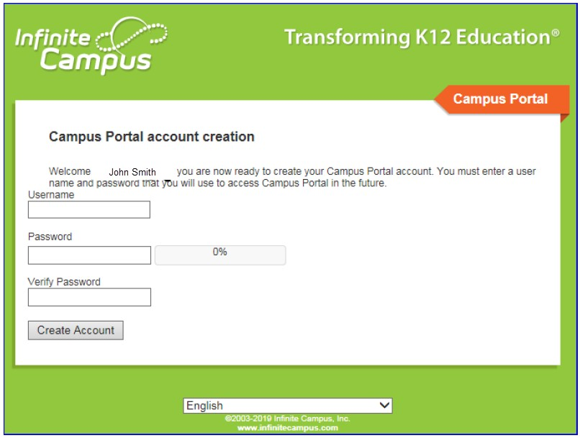
Create a Username and Password of your choice and click the Create Account button.
After successfully creating your account, use the Click Here hyperlink to access the login screen
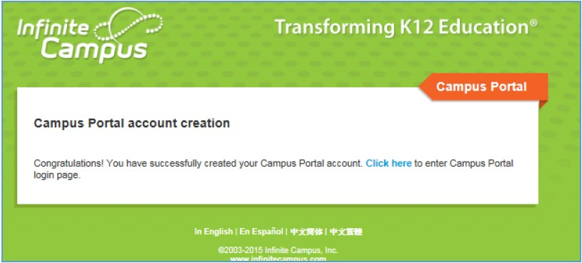
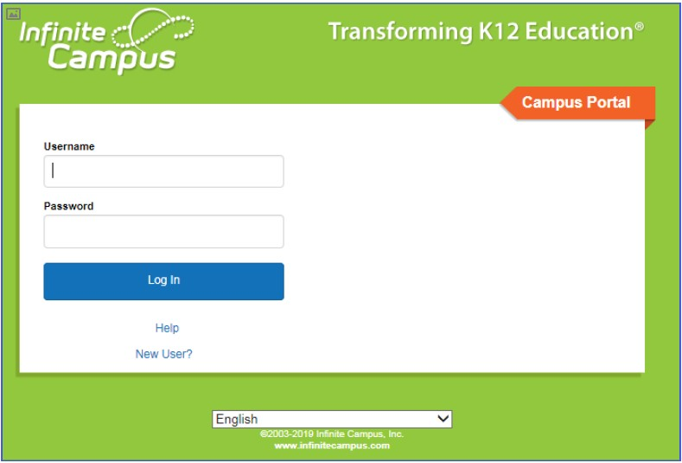
Enter the Username and Password you just created to log into the Parent Portal:

Creating an account is only required once to gain access to the Parent Portal. After a Username and Password have been created, parent/guardians should simply go straight to the Campus Portal for Students and Parents login screen for future logins.

