Complete your Dual Enrollment Funding Application
If you do not complete this form within the first two weeks of class, you will be responsible for payment of the tuition and fees associated with your dual enrollment courses. If you need assistance, please contact Ms. Browning through the Remind app.
Text @lccadu to 81010

- Create a GA Futures account at http://www.gafutures.org/
Make a note of your log-in ID and password. You will need this information several times over the coming years.
*If you do not have a Social Security number, please leave that question blank and see further instruction at the bottom.

- Once your account is created, on the left side of the screen, select My Dual Enrollment Profile
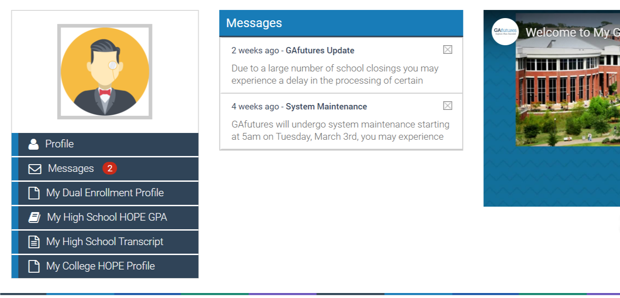

- Click on Apply Now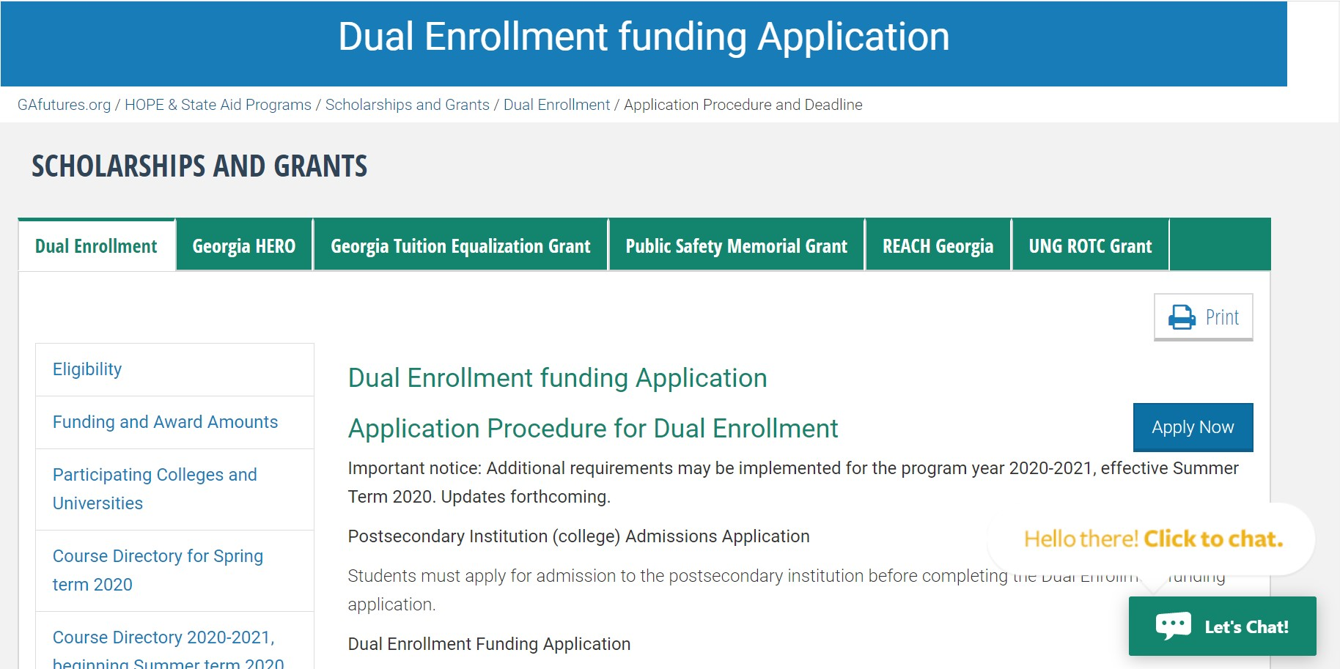
- Click on Apply for Dual Enrollment
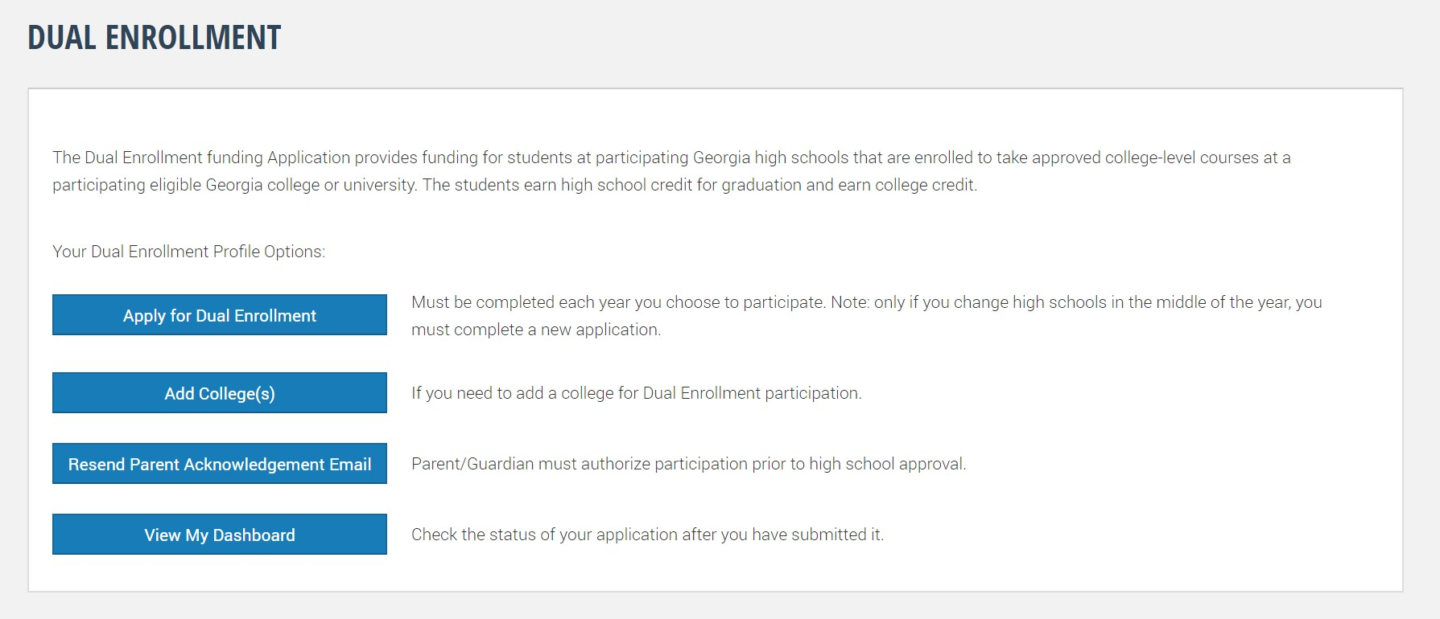
- Complete the form, including Parent/Guardian Email Address
*If your parent or guardian does not have an email address, they will need to visit GAFutures.org/DEparent after you submit the application, complete the form and return to your home high school
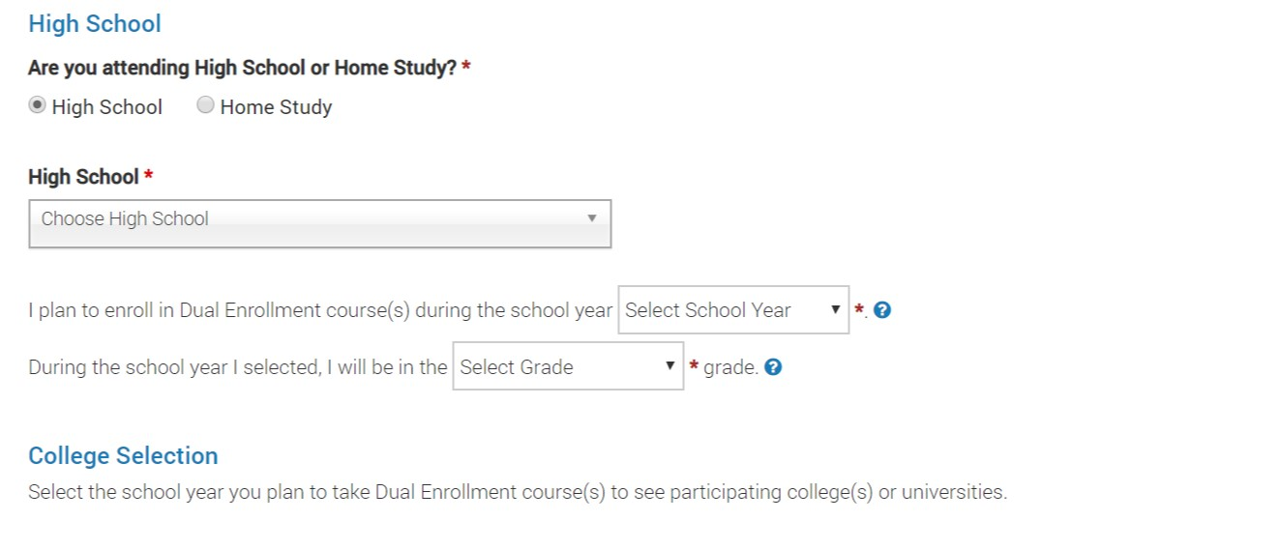
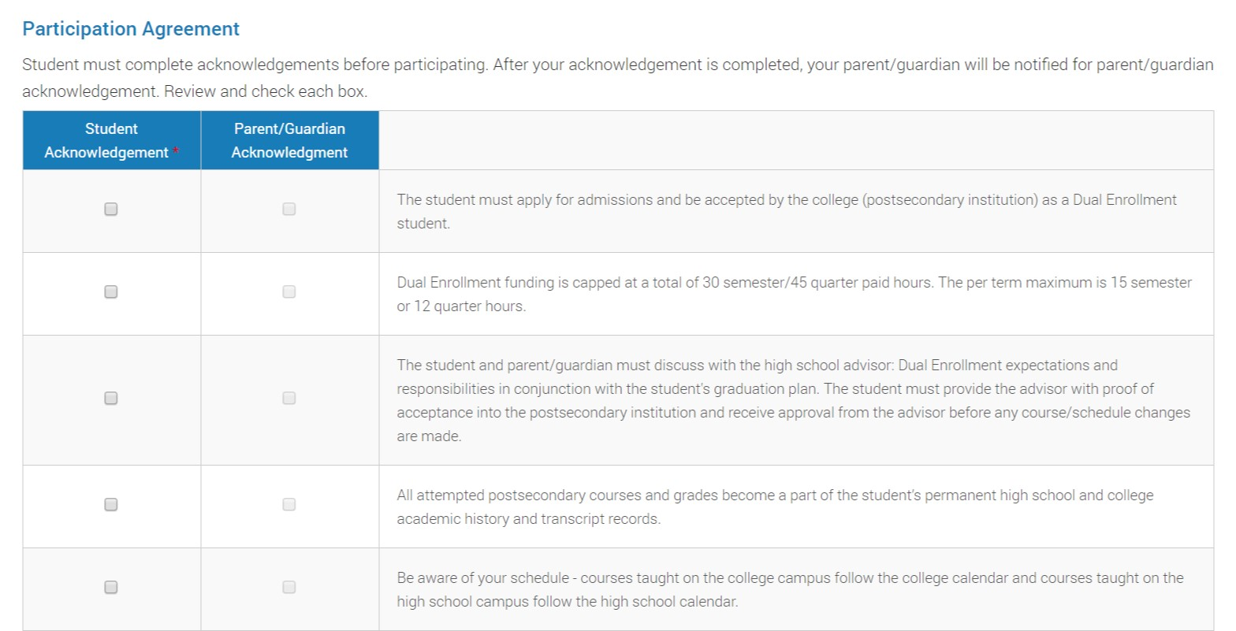

- Acknowledge HOPE Grant implications, sign, and Submit
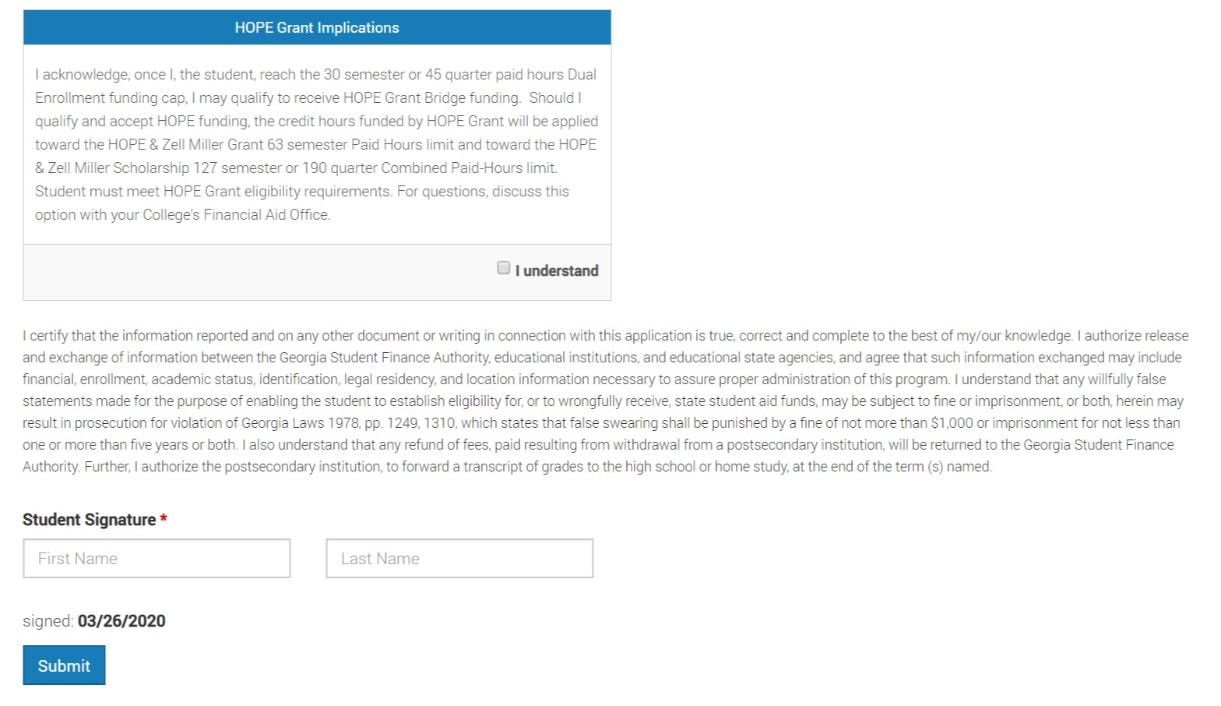
- Your parent/guardian should receive an email to complete their portion of the application. Once submitted, the application will be sent to your home high school. This process must be completed before Lanier Tech can register you for courses.

For students without a Social Security number:
After clicking on Apply for Dual Enrollment, you will be required to verify that you do not have a Social Security number.
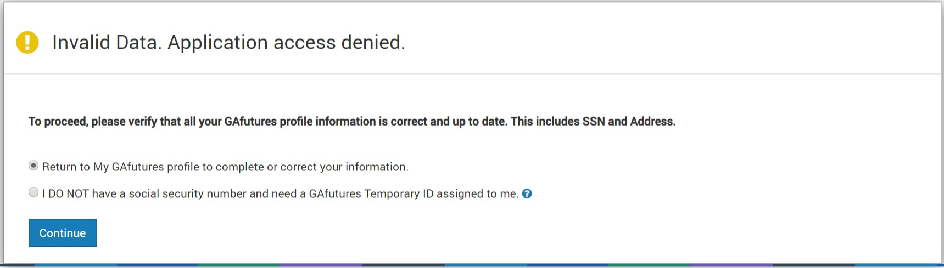
GAFutures will issue you a Temporary ID that will be used to identify you and process your application.

